A Peek into Space Preferences Based on Big Five Personality and Impression Management

Daisy Cho

Macalester College

Abstract

Everyday millions of people make consumer-related decisions that reflect their identities, politics, and personalities. The current study looks into the association between spatial preferences, openness to experience, and impression management. Based on past studies, spatial cue preferences that signal openness was hypothesized to be correlated to openness to experience Gosling, Ko, Mannarelli & Morris, 2002). Past articles also indicated that spatial cues represents status and relations, so impression management was hypothesized to be correlated with preferences for more conventional spaces (Gram-Hanssen & Bech-Danielsen, 2004). Conducting a series of bivariate of correlations, the current study found that there was a positive correlation between rooms with no wall décor and impression management. However, openness to experience was not significantly correlated to cues that signal openness to experience. Public self-consciousness was also generally not significantly correlated to any of the spaces the represent conventional cues.

*Keywords*: Space preferences, Public self-consciousness, Impression management, Openness to experience

Using Big Five Personality and Impression Management to Predict Cue Interests

The FBI, the CIA, and Sherlock Holmes all use identifiable evidence in order to pick up information about the perpetrator of a crime. However, observational skills are not only used in detective stories or crime fighting films. People use these skills in everyday situations just through a greeting or in noticing the items a person owns (Gosling, 2008). In this consumer based society, people buy certain items and organize their living spaces in a way that may present aspects of the owner’s identity, such as their personality traits (Gosling, 2003; Gosling, Ko, Mannarelli & Morris, 2002). Interactionist theories state that people create environments that match and presents their interests, views and preferences (Buss, 1977). Although living spaces, such as bedrooms and office spaces, are created by the owner’s preferences, it is not well understood if the products that populate and decorate our personal spaces are chosen more as a function of internal qualities, such as personality, or social qualities, such as impression management.

Personality appears to be strongly reflected in the setup of offices and bedrooms, and in musical tastes. Many studies concluded that one of the ways people judge others is based on appearance. One influential study on personality-judgment at zero-acquaintance – that is, when people first meet one another – concluded that a well-dressed appearance was correlated with conscientious whereas attractiveness was correlated to extraversion (Albright, Kenny & Malloy, 1988). In other research, people who presented themselves more professionally appearance-wise were perceived as being more agreeable and intelligent over those who do not present themselves in that way, even if targets in both groups scored equally high IQ scores (Human, Biesanz, Parisotto & Dunn, 2012). People’s impressions on others is based on the target individual appearance and interactions rather than onlooker’s attitude towards meeting and interacting with the target individual (Huttner & Linden, 2017). Also, similarly to Albright et al. (1988) and Human et al. (2012), Huttner and Linden (2017) found that the outer appearance of a person can have a significant impact on a perceiver’s outlook of the target, such as if the target is using make-up, their hairdo is neat, and they are well-dressed. All these studies show that appearance, from our faces to our clothing, influences how others judge us. From these studies, the presentation of oneself is deemed important especially when it comes to zero-acquaintance judgment. Therefore, people would usually try to look their best in order to be perceived in a more agreeable and approachable manner.

Previous research has found that some environmental cues in specific living spaces, such as in the bedroom and office area, can help a third party accurately determine the personality traits of the owner (Gosling et al., 2002). Brunswick’s (1956, cited in Albright, Kenny & Malloy, 1988; Gosling et al., 2002) lens model provides a basis for the Gosling et al. (2002) study using cue utilization, using observable cues and connecting them to the observer’s judgment, and cue validity, the connection between the environmental cue and the owner’s personality traits. The cue can be anything from body movement, such as arm movement, to environmental cues, such as the dimness or organization in a room. In the personality and living space study, occupants observed a living space and rated the owner’s big five personality traits using the environmental cues in the owner’s living space, such as odor, noise in room, number of books, organized items. The results showed that the participants of the study can use certain environmental cues to predict certain personality traits of the owner of the room accurately; in other words, the cue validity correlation trend matched up with the cue utilization correlation trend (Gosling et al., 2002). Cues can also be seen directly on humans ranging from something as passive as soft facial lineaments, which is correlated to agreeableness, to dynamic actions such swinging your arms when walking, which is correlated to extraversion (Gosling, 2008). Past studies found that observers are accurate in determining some degree of extraversion and openness when just looking at the target’s face with no special expressive behavior, such as a smile or eyebrow raise, but when nonverbal expressive behavior is visible, observers were more accurate when determining the target’s conscientiousness, agreeableness, extraversion and openness (Naumann, Vazire, Rentfrow & Gosling, 2009). Gosling (2008) also noted that, regardless of the cues, it is easier to identify visible traits, such as extraversion, rather than agreeableness, neuroticism, and openness.

Another study that uses cues to predict personality shows the association between music genre cues and the correlation to certain Big Five personality traits (Rentfrow & Gosling, 2003). Music preference was also correlated to the Big Five personality traits in other work conducted by Gosling and his colleagues. Instead of environmental cues, this study looked into musical cues and determined which personality traits are correlated to different cues. For example, upbeat and conventional music were positively correlated to extraversion, agreeableness, conscientiousness, emotional stability, and negatively correlated to openness (Rentfrow & Gosling, 2003). Unlike the environmental cues, however, the musical cues represented music the participants enjoyed listening to whereas the environmental cues were rooms already created by the owners before being used for a study. Therefore, if preferences to music can predict personality, there may also be a correlation between personality and other consumer preferences related to designing personal spaces.

In order to provide a stronger basis for this argument, a connection between consumer habits and personality must be determined. In the domain of personality, for example, researchers have found that extraversion and neuroticism are positively related to impulse buying (Olsen, Tudoran, Honkanen & Verplanken, 2016), and openness to experience is positively related to the willingness to buy online (Bosnjak, Galesic & Tuten, 2007). These studies shows that there is a correlation between consumer practices and personality traits. Those who are more willing to shop online are higher to openness to experience and may have preferences for items that are easily obtainable online.

In order to create a more appealing impression on others, people are expected to carefully decide on the items they choose and the clothes they wear. According to Bushman (1993), people who are highly self-conscious are very concerned about the impression they make on others. In Bushman’s (1993) study, public self-consciousness was used to operationalize the concept of impression management in Bushman’s (1993) work. The study showed that product ratings for national brand names, such as *Smucker’s* and *Advil,* were positively correlated with public self-consciousness whereas bargain brand names, such as *Billy boy* and *Up & Up,* were negatively correlated with public self-consciousness (Bushman, 1993). Overall, those who had higher levels of public self-consciousness chose to buy national brand names and those with lower public self-consciousness would buy bargain brand names. Aside from groceries, luxury brand are powerful status symbols, but many people cannot afford this and instead purchase counterfeit versions that fulfill the social goals of creating an impression on others that they belong to a higher social class (Wilcox, Kim & Sen, 2009). Therefore, people are willing to buy these expensive items or similar counterfeits in order to manage the impressions of those around them. In addition to specific individual items, space may also predict public self-consciousness. Concern about one’s public image is related to preferences for household items and decorations. The furniture and items in a house represent the owner’s social life and serve as status symbols and symbols of relations within the family (Gram-Hanssen & Bech-Danielsen, 2004). Therefore, those with higher public self-consciousness would showcase items that represent family relations, such as family portraits, and status symbols, such as sports trophies or a Purple Heart medal.

A critical question concerns whether or not impression management is associated with an individual’s personality. One study found that there is a weak correlation between impression management and Big Five personality traits. In one study, applicants were given a Big Five personality questionnaire, and in order to show themselves in a better light, the applicants would answer the questions which seemed most favorable for the job position (Barrick and Mount, 1995). The results showed, however, that the outcome of the personality tests were not different from the applicants’ actual personalities. Even though the applicants wanted to answer a personality survey that would make them seem best suited for the job, they did not choose answers that deviated much from their actual personality (Barrick and Mount, 1995). Another study measured if people chose to create city spaces on CityVille that are more associated with their ideal personality, the personality traits the player wants to have or portray, or their actual personality traits (Wohn & Wash, 2013). Wohn and Wash (2013) believed that the difference between the participant’s ideal personality traits and their actual personality traits would be explained by levels of impression management, which was operationalized by public self-consciousness (Fenigstein, Scheier & Buss, 1975). However throughout the period CityVille was played, the observed personality traits was closer to the player’s real personality than the ideal personality, and the difference was significant for all five personality dimensions (Wohn & Wash, 2013). The results show that public self-consciousness levels did not have any significant association to the preferences on how the city was built partially because the game was private. The city was rarely viewed by other people, and even if it was, there was limited choices on how the city can be built. Overall, Wohn and Wash (2013) found that it is difficult to be heavily influenced by public self-consciousness on games that are less socially interactive with other players.

Because past research shows that impression management does not seem easily predicted through personality surveys and spatial simulations, there should be minimal correlation between public self-consciousness and impression management. According to an Estonian study, which measured the correlation between the NEO personality survey and the public self-consciousness scale, public self-consciousness was significantly correlated to neuroticism (Realo & Allik, 1998). Because public self-consciousness was only correlated to neuroticism, I chose to specifically look at one of the less predictable traits, openness to experience (Gosling, 2008).

Because Gosling and colleagues found that personality can be accurately predicted by particular cues, the current study predicts that preferences for particular cues can be predicted by personality. It is possible, however, that public self-consciousness, rather than personality, is a stronger predictor of room preferences (Wilcox et al., 2009). The current study is designed to test these alternative hypotheses by assessing Big 5 personality traits (focusing primarily on openness to experience), public self-consciousness, and preferences for spaces that include cues that have strong cue validity related to openness to experience in Gosling’s work.  If personality predicts cue preference, then openness to experience should be significantly correlated with space preferences that signal openness, or more unconventional spaces.  If, in contrast, cue preference is a function of how much people care about what others think about them, then impression management, operationalized by public self-consciousness, should be significantly correlated with preferences for more conventional spaces. Because measures of public self-consciousness appear to be unrelated to measures of openness to experience (Realo & Allik, 1998), they can be considered independent predictors of cue preferences.

**Method**

**Participants**

Participants were recruited through posting on the Macalester Facebook page and via other contacts. We recruited 110 participants (70 females, 26 males, 3 non-binary), 82 were between the ages of 18 and 22, 15 were 23-29, one was 30-39, two were 40 or older. Among the participants, 31 were White, 63 were Asian, three were African-American, and three were Latinx. Two participants self identified as upper class, 58 were in the upper-middle class, 29 were in the lower-middle class, 9 were in the lower class and two participants were poor. Of all these responses, 100 participants were included in the analysis based on their completion of the survey. Participation was voluntary, and participants did not receive any compensation.

**Design**

The study was a multivariate correlational design with two predictor variables, one covariate and one outcome variable. The first predictor variable was level of openness to experience, and the other predictor variable was public self-consciousness. Family economic standing was the covariate. The outcome variable was space preferences.

**Measures**

**Openness to experience.** Openness to experience was measured using the M5-50 International Personality Item Pool (M5-50 IPIP; Socha, Cooper & McCord, 2010). The M5-50 is a revised version of the IPIP, consisted of 10 items that are most correlated to each personality trait in the five-factor model: agreeableness, extraversion, openness to experience, neuroticism and conscientiousness. However, for this experiment we will only be looking at openness to experience. Participants used a five-point scale (1 = *inaccurate* to5 = *accurate*) to indicate the extent to which they agreed that the ten statements pertained to them (e.g., “Have a vivid imagination”). The M5-50 IPIP has a reliability of .82 for openness to experience (Socha, Cooper & McCord., 2010). In the current sample, the alpha coefficient was .745 for openness to experience.

**Public self-consciousness.** Impression management was operationalized by using the self-consciousness scale (Fenigstein, Scheier & Buss, 1975). This scale originally consisted of 23 items; however, because I am only concerned with the aspect of self-consciousness that relates to a concern with what others think, I will only use the seven questions that assess public self-consciousness (e.g., “I’m concerned about the way I present myself”). Each item was rated on a 5-point scale (0 = *extremely uncharacteristic* to4 = *extremely characteristic*) to indicate the extent to which they believe the statement pertained to them. This original public self-consciousness scale had a reliability of .84 for public self-consciousness (Fenigstein et al., 1975). In the current sample, the alpha coefficient was .781.

**Space preference rating.** Participants were shown instructions that stated, “Assuming you were interested in spending, and were able to spend, the resources that are needed for decorating spaces in these ways, please rate how willing you would be to live or work in the spaces pictured below. You can also imagine that you could change the colors or the exact kind of art, or rearrange the furniture within a room, in a way that you might like better.” Then, participants were presented with eight images of different spaces or areas of a room (obtained from a Google images search; see Appendix A) of certain items in random order. Spaces were selected to reflect the environmental cues that most reliably predicted owner’s openness to new experience in Gosling et al. (2002). Participants rated how willing they would be to live or work in a space similar to the one in the image. The spaces presented were rooms with and without art wall decor, a conventional/unconventional office, a stylish/unstylish office, a distinctive/ordinary bedroom. The rating scale was developed for the purpose of this study and was not taken from previous studies. The ratings of the images are summarized by each environmental cue (e.g., stylish/unstylish) independently. The reliability coefficient for the overall environmental cues was .176. The no art wall décor, conventional, ordinary and unstylish rooms had a reliability coefficient of .531. The wall art décor, stylish, unconventional, and distinctive rooms had an acceptable reliability coefficient of .640.

**Procedure**

Participants clicked on a link on a Facebook post or e-mail that directed them to the online study developed on Qualtrics. Participants were asked to read and agree to the consent form before participating in the study. After consenting, participants were presented eight images in random order and rate the appeal of working or living in the presented space. For each participant, the space preference images were put in random order to control for order effects. Following this, the openness to experience scale and the public self-consciousness scale were presented. Finally, the participants will fill out a form with demographic questions. At the end of the study, participants were presented with a debriefing form and thanked for their time.

**Results**

Self-rating social class background was unrelated to all space cues (correlation coefficients range from -.06 to .16); social class was not, therefore, used as a covariate in any analyses. Due to the low reliability coefficients for the overall environmental cues and the combined conventional cues, I ran individual correlational analyses between each of these cues and openness to experience, and public self-consciousness. The wall art décor, stylish, unconventional, and distinctive room had an acceptable reliability coefficient so these were averaged into an *unconventional cues* variable that was correlated with both openness to experience and public self-consciousness.

To examine associations between openness to experience, public self-consciousness and environmental cue preferences, I conducted a series of bivariate correlations. Public self-consciousness was positively correlated to rooms with no wall décor (*r* = .29, *p* = .004). However, there were no significant correlation between public self-consciousness and the unconventional cues (*r* = .15, n.s.), the unstylish office (*r* = -.01, n.s.), conventional office (*r* = -.04, n.s.), and the ordinary room (*r* = .11, n.s.). There were no significant correlation between openness to experience and the unconventional cues (*r* = -.003, n.s.), no wall art décor room (*r* = -.07, n.s.), the unstylish office (*r* = .02, n.s.), conventional office (*r* = .13, n.s.), and the ordinary room (*r* = -.19, n.s.).

**Discussion**

The present study examined the correlations among openness to experience, public self-consciousness, and spatial preferences based on environmental cues. Building on past research, I hypothesized that more unconventional rooms will be positively correlated to openness to experience (Gosling et al., 2002), and more conventional room will be positively correlated to public self-consciousness (Wilcox et al., 2009).

My results were generally unsupportive of both of my hypotheses. Openness to experience was not significantly correlated to unconventional cues, although there was a non-significant positive correlation between these variables. Public self-consciousness was also generally not significantly correlated to any of the conventional cues except with the room with no wall art decor. Another interesting outcome, although non-significant, was how unstylish office and unconventional office preferences were positively correlated to openness to experience, but negatively correlated to public self-consciousness.

There may be several reasons why we found these results. The first reason is that a room created by the owner may be correlated to their personality (Gosling et al., 2002), but their preferences when looking at pre-decorated room may not be correlated to personality. In the previous study that measured the correlation between environmental cues and owner personality traits, the rooms used in the study were rooms already created by the owners personally regardless how long it took to create a space that was correlated to their personality (Gosling et al., 2002). However, in my study, I chose the images of rooms that can be examples of certain environmental cues and asked people, who do not have any personal association to the space, to rate how much they are willing to live or work in the presented space. The level of intimacy between the owner and the room, or participant and the space, may also play a role in how personality traits are portrayed through certain environmental cues in a room. This can be supported by the Gosling (2002) study, in which the environmental cues significantly correlated to personality traits is developed from personal living space cue inventory consisting of the environmental cues is developed by analyzing already existing rooms (Gosling et al., 2005). This may also explain why the unstylish office and conventional office cue preferences did not align with my hypotheses.

Another reason may be that although environmental cues can be used to predict the owner’s personality, preferences for certain unconventional and most conventional spaces are not predicted by openness to experience or public self-consciousness levels. The study I conducted may have been more of a measurement of cue utilization, using observable cues and connecting them to the observer’s judgment, rather than cue validity, the connection between the environmental cue and the owner’s personality traits. The rooms may have been rated, not by how the participants would personally design their own room, but by how attractive the room looked (Albright, Kenny & Malloy, 1988; Gosling et al., 2002). Although I was looking at the cue validity between the participants and the images representing specific environmental cues, it may have been unclear that the participants should have been thinking in the mindset that they would actually design their own personal room in a similar way. Therefore, there may have been fewer significant results between the environmental cue preferences, openness to experience and public self-consciousness (Gosling et al., 2002). Also, specifically for public self-consciousness, because others do not see the ratings the participants made, the participants may not have felt under the constraints of having to portray a certain impression to others (Bushman, 1993; Wohn & Wash, 2013).

There was, however, one significant result that stood out from the other environmental cue preferences: the image of the room with no wall art décor was significantly correlated to public self-consciousness. There are two possible reasons for this outcome. First, this image may have been a good item used to represent a room without any wall art décor. The image itself was a bare room with only a bed and there were very little decoration and color, if any. Therefore, the owner of the room either may not like showcasing their status or family relationships, or choose to keep an extremely conventional minimalist design, because of higher levels public self-consciousness (Gram-Hanssen & Bech-Danielsen, 2004; Wilcox et al., 2009). Second, the room with no art wall décor predicted by public self-consciousness may also indicate that concern with public image motivates some design preferences. It may not have any psychological explanation to it, but the participants, as stated before, just enjoyed the design more if they were higher on public self-consciousness. The skepticism for the significant results comes from the fact that other conventional cues did not produce significant results.

**Limitations**

One of the limitations of the study may be the small sample size which reduces the variability of the data. Another limitation would be the low reliability coefficients of the combined spatial image cues. If the images were pre-tested to see which images are correlated to certain personality, there may have been more significant results consistent with past studies. Also, Gosling et al.’s (2002) study described cues based on bipolar adjectives (e.g. Distinctive vs. Ordinary) whereas I created separate images for both (one image for distinctive room and one for ordinary room) and made it seem like there are two separate environmental cues when they are both of the same environmental cue, which may have given greater room for error in the study because the two images may not have been exact counterparts of each other.

**Future Directions**

In future research, pre-testing the environmental cues in relation to observer personality ratings should be conducted to account for reliability and retest. Another possible direction of the study, however, would be to expand study by looking at cue preferences correlated to the other Big Five personality traits. Another direction would be to look at other consumer preference trends such as clothing. There are studies showing the correlation between the owner’s personality and the spaces they create, but there are no studies that have strong results supporting the correlation between the owner’s personality and clothing items they already own. However, there are individual clothing items, such as formal dresses have been found to be correlated with conscientiousness (Gosling, 2008). One last direction that can be looked into would be to create an experimental study focusing on environmental cues correlated to certain personality traits and public self-consciousness by priming some participants to be more publicly self-consciousness and then rating their spatial preferences on room images.

**Conclusion**

This research takes a look at spatial preferences of different living and working spaces based on environmental cues, and the correlation between these preferences and openness to experience and public self-consciousness. From this study, I established that only preferences for rooms with no wall art décor is correlated to public self-consciousness. However, other cues were not correlated to public self-consciousness or openness to experience. The findings highlight that spatial preferences do not appear to have the same association to openness to experience or public self-consciousness as living or working in the space in person. Overall, the research found that the owner’s own space can be helpful in determining the owner’s personality in situations such as criminal investigations, the preferences for certain spaces are not accurate indications of a person’s personality or public self-consciousness levels.

References

Albright, L., Kenny, D. A., & Malloy, T. E. (1988). Consensus in personality judgments at zero acquaintance.*Journal of Personality and Social Psychology, 55*(3), 387-395. doi:10.1037/0022-3514.55.3.387

Barrick, M. R., & Mount, M. K. (1996). Effects of impression management and self-deception on the predictive validity of personality constructs.*Journal of Applied Psychology, 81*(3), 261-272. doi:10.1037/0021-9010.81.3.261

Bosnjak, M., Galesic, M., & Tuten, T. (2007). Personality determinants of online shopping: Explaining online purchase intentions using a hierarchical approach.*Journal of Business Research, 60*(6), 597-605. doi:10.1016/j.jbusres.2006.06.008

Bushman, B. J. (1993). What's in a name? The moderating role of public self-consciousness on the relation between brand label and brand preference. *Journal of Applied Psychology*, *78*(5), 857.

Buss, A. R. (1977). The trait-situation controversy and the concept of interaction.*Personality and Social Psychology Bulletin, 3*(2), 196-201. doi:10.1177/014616727700300207

Fenigstein, A., Scheier, M. F., & Buss, A. H. (1975). Public and private self-consciousness: Assessment and theory.*Journal of Consulting and Clinical Psychology, 43*(4), 522-527. doi:10.1037/h0076760

Gosling, S. (2008). *Snoop: What your stuff says about you.* NY: Basic Books.

Gosling, S. D., Craik, K. H., Martin, N. R., & Pryor, M. R. (2005). Material attributes of personal living spaces. *Home Cultures*, *2*(1), 51-87.

Gosling, S. D., Ko, S. J., Mannarelli, T., & Morris, M. E. (2002). A room with a cue: Personality judgments based on offices and bedrooms.*Journal of Personality and Social Psychology, 82*(3), 379-398. doi:10.1037/0022-3514.82.3.379

Gram-Hanssen, K., & Bech-Danielsen, C. (2004). House, home and identity from a consumption perspective. *Housing, theory and society*, *21*(1), 17-26.

Human, L. J., Biesanz, J. C., Parisotto, K. L., & Dunn, E. W. (2012). *Your best self helps reveal your true self*. Los Angeles, CA: SAGE Publications. doi:10.1177/1948550611407689

Huttner, S., & Linden, M. (2017). Modification of first impression formation and 'personality' by manipulating outer appearance. *Psychopathology, 50*(2), 141-145. doi:10.1159/000453585

Naumann, L. P., Vazire, S., Rentfrow, P. J., & Gosling, S. D. (2009). Personality judgments based on physical appearance. *Personality and Social Psychology Bulletin, 35*(12), 1661-1671. doi:10.1177/0146167209346309

Olsen, S. O., Tudoran, A. A., Honkanen, P., & Verplanken, B. (2016). Differences and similarities between impulse buying and variety seeking: A personality-based perspective.*Psychology & Marketing, 33*(1), 36-47. doi:10.1002/mar.20853

Realo, A., & Allik, J. (1998). The Estonian self-consciousness scale and its relation to the Five-Factor Model of personality.*Journal of Personality Assessment, 70*(1), 109-124.

Rentfrow, P. J., & Gosling, S. D. (2003). The do re mi's of everyday life: The structure and personality correlates of music preferences.*Journal of Personality and Social Psychology, 84*(6), 1236-1256. doi:10.1037/0022-3514.84.6.1236

Socha, A., Cooper, C. A., & McCord, D. M. (2010). Confirmatory factor analysis of the M5-50: An implementation of the international personality item pool item set.*Psychological Assessment, 22*(1), 43-49. doi:10.1037/a0017371

Wilcox, K., Kim, H. M., & Sen, S. (2009). Why do consumers buy counterfeit luxury brands?*Journal of Marketing Research (JMR), 46*(2), 247-259. doi:10.1509/jmkr.46.2.247

Wohn, D. Y., & Wash, R. (2013). A virtual 'room' with a cue: Detecting personality through spatial customization in a city simulation game.*Computers in Human Behavior, 29*(1), 155-159. doi:10.1016/j.chb.2012.07.029

Table 1

*Correlations Between Openness to Experience, Public Self-consciousness and Environmental Cues*

|  |  |  |
| --- | --- | --- |
| Environmental cues | Openness to experience | Public self-consciousness |
| Unconventional cues | .003 | .15 |
| No wall art décor | -.07 | .29** |
| Unstylish office | .02 | -.01 |
| Conventional office | .13 | -.04 |
| Ordinary room | -.19 | .11 |

**Appendix A**

Wall Decor: Art (e.g. Van Gogh)

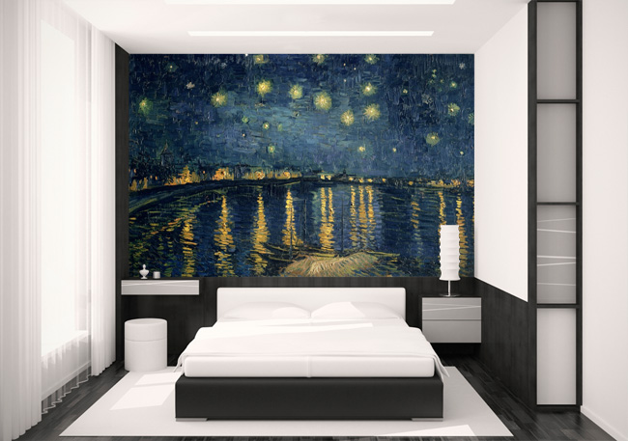

No art décor

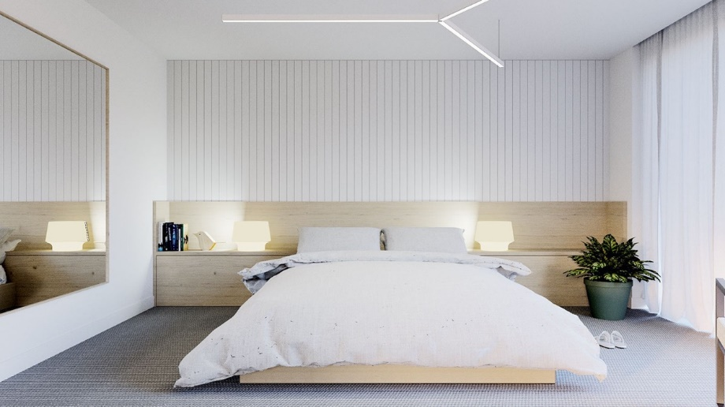

Stylish Office space

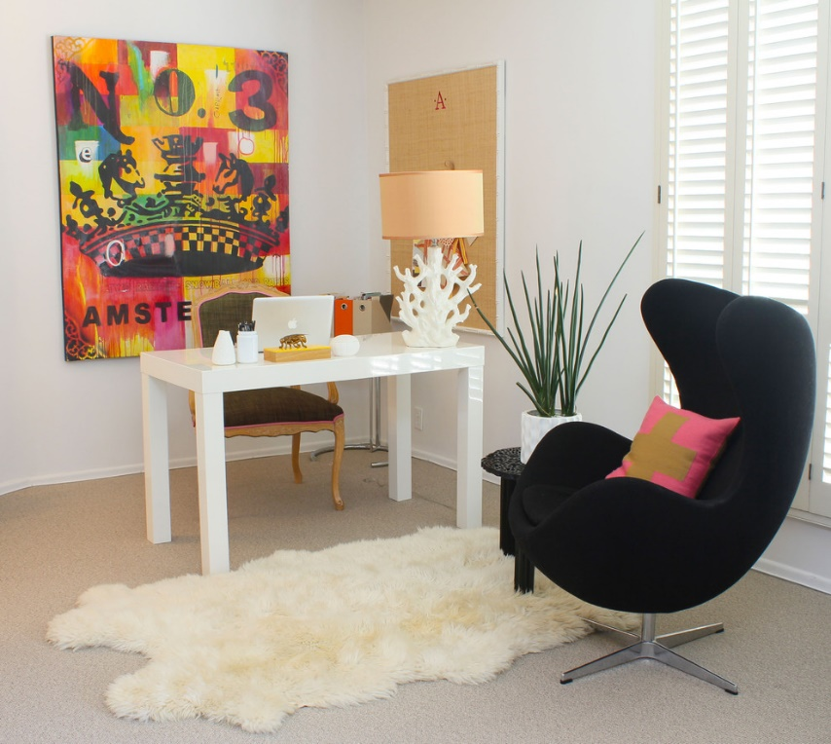

Unstylish Office space

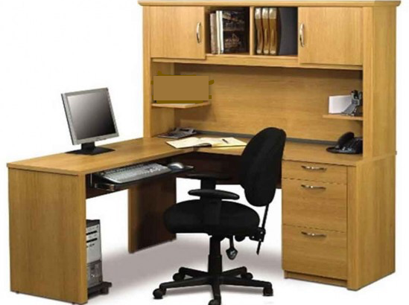

Conventional office

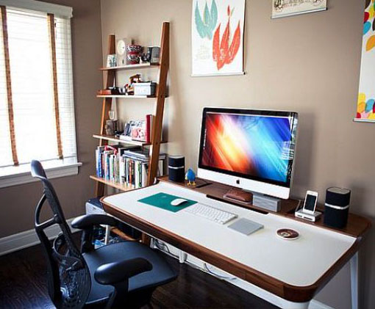

Unconventional office

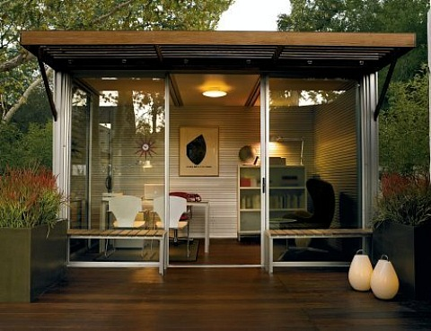

Distinctive bedroom

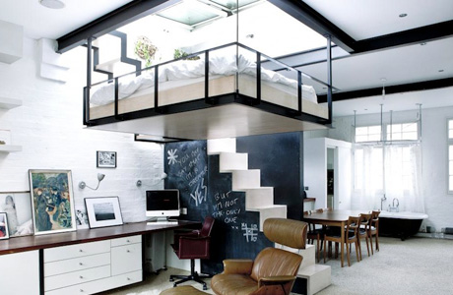

Ordinary bedroom

